**Experiment No . 1**

**Title:** Introduction to .NET architecture and simple c# program execution.

**Name:** Vaishnavi Kumar Sutar

**Roll No :** 54 **Batch :** T3

**1.Write a simple c# program.**

using System;

using System.Collections.Generic;

using System.Linq;

using System.Text;

using System.Threading.Tasks;

namespace helloworld

{

class Program

{

static void Main(string[] args)

{

Console.WriteLine("Hello World");

Console.ReadLine();

}

}

}

**Output:**

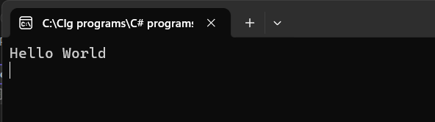

**2.Write program of arithmetic operations using switch case.**

using System;

using System.Collections.Generic;

using System.Linq;

using System.Text;

using System.Threading.Tasks;

namespace Arith_Operations

{

class Program

{

static void Main(string[] args)

{

int num1, num2;

Console.Write("Enter the num1: ");

num1 = Convert.ToInt32(Console.ReadLine());

Console.Write("Enter the num2: ");

num2 = Convert.ToInt32(Console.ReadLine());

Console.WriteLine("1.Addition");

Console.WriteLine("2.Subtraction");

Console.WriteLine("3.Multiplication");

Console.WriteLine("4.Divsion");

Console.Write("Choice: ");

int choice = Convert.ToInt16(Console.ReadLine());

switch (choice)

{

case 1:

Console.WriteLine("Addition of two numbers: " +(num1 + num2));

break;

case 2:

Console.WriteLine("Subtraction of two numbers: " +(num1 - num2));

break;

case 3:

Console.WriteLine("Multiplication of two numbers: " +num1 * num2);

break;

case 4:

Console.WriteLine("Division of two numbers: " +num1 / num2);

break;

default:

Console.WriteLine("Sorry! Choice is not available ");

break;

}

Console.ReadLine();

}

}

}

**Output:**

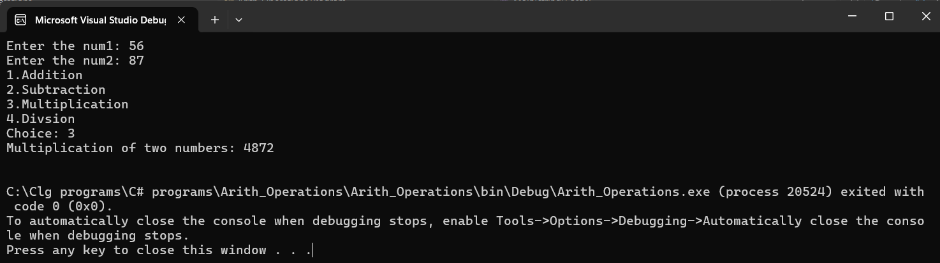

**Experiment No . 2**

**Title:** Implementation of OOPs concepts in c# class, inheritance, extension method.

**Name:** Vaishnavi Kumar Sutar

**Roll No :** 54 **Batch :** T3

**1.Class and Object**

using System;

using System.Collections.Generic;

using System.Linq;

using System.Text;

using System.Threading.Tasks;

namespace classobject

{

class Dog

{

string breed;

public void bark()

{

Console.WriteLine("Bark Bark!!");

}

static void Main(string[] args)

{

Dog bullDog = new Dog();

bullDog.breed = "Bull Dog";

Console.WriteLine(bullDog.breed);

bullDog.bark();

Console.ReadLine();

}

}

}

**Output :**

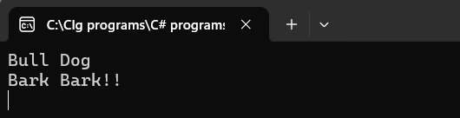

**2.Inheritance:**

using System;

using System.Collections.Generic;

using System.Linq;

using System.Text;

using System.Threading.Tasks;

namespace inheritance

{

//base class

class Animal

{

public string name;

public void display()

{

Console.WriteLine("I am an animal");

}

}

// derived class of Animal

class Dog : Animal

{

public void getName()

{

Console.WriteLine("My name is " + name);

}

}

class Program

{

static void Main(string[] args)

{

// object of derived class

Dog labrador = new Dog();

// access field and method of base class

labrador.name = "Rohu";

labrador.display();

// access method from own class

labrador.getName();

Console.ReadLine();

}

}

}

**Output:**

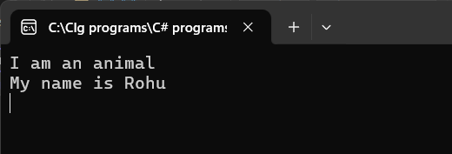

**3.Extension Method:**

ClassLibExtMethod:

using System;

using System.Collections.Generic;

using System.Linq;

using System.Text;

using System.Threading.Tasks;

namespace ClassLibExtMethod

{

public class Class1

{

public string Display()

{

return ("I am in Display");

}

public string Print()

{

return ("I am in Print");

}

}

}

ExtensionMethod1.cs

using System;

using System.Collections.Generic;

using System.Linq;

using System.Text;

using System.Threading.Tasks;

using ClassLibExtMethod;

namespace ExtensionMethod1

{

public static class xx

{

public static void NewMethod(this Class1 ob)

{

Console.WriteLine("Hello I am extended Method");

}

}

class Program

{

static void Main(string[] args)

{

Class1 ob = new Class1();

ob.Display();

ob.Print();

ob.NewMethod();

Console.ReadKey();

}

}

}

**Output:**

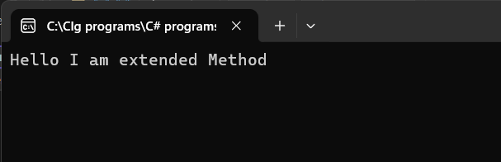

**Experiment No . 3**

**Title:** Develop a DLL file and use it in application program.

**Name:** Vaishnavi Kumar Sutar

**Roll No :** 54 **Batch :** T3

Calculation_Library:

using System;

using System.Collections.Generic;

using System.Linq;

using System.Text;

using System.Threading.Tasks;

namespace Calculation

{

public class calculate

{

public int Add(int a, int b)

{

return a + b;

}

public int Sub(int a, int b)

{

return a - b;

}

}

}

CalculationApp:

using System;

using System.Collections.Generic;

using System.Linq;

using System.Text;

using System.Threading.Tasks;

using Calculation;

namespace CalculationApp

{

class Program

{

static void Main(string[] args)

{

calculate calc = new calculate();

// Perform Addition

int sum = calc.Add(15, 10);

Console.WriteLine("Addition Result: " + sum);

// Perform Subtraction

int difference = calc.Sub(20, 5);

Console.WriteLine("Subtraction Result: " + difference);

Console.ReadLine();

}

}

}

**Output:**

